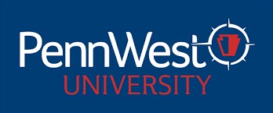

PENNSYLVANIA WESTERN UNIVERSITY
UNIVERSITY-WIDE CONTRACTUAL COMMITTEES
2024-2025 ACADEMIC YEAR

SABBATICAL COMMITTEE 2024 – 2025 AY

College of Education, Arts, & Humanities
Marc Sanko (CL) Criminal Justice, History & Politics/History 2025
Steve Sullivan (ED) English, Modern Languages & Philosophy/Philosophy 2025
Jennifer Boyer (CL) Criminal Justice, History & Politics/Criminal Justice 2026
Mary Nientimp (ED) Education/Special Education 2026

College of Health Sciences & Human Services
Codie Stone (CAL) Social Work, Sociology & Human Services/Sociology 2025
Natalie Armstrong(CL) Communication Sciences & Disorders/Speech Path 2025
Molly Wolf (ED) Social Work, Sociology & Human Services/Social Work 2025
Nicole Evanick (CAL) Nursing & Health Professions/Nursing 2026
Joyce Jagielo (ED) Psychology, Counseling & Art Therapy/Psychology 2026

College of Science, Technology, & Business
Chad Kauffman (CAL) Biology, Earth & Environmental Sciences/Atmospheric Science 2025
Ambreena Siddiq (CL) Chemistry, Mathematics & Physics/Chemistry 2026
Jingze Jiang (ED) Business, Economics & Communication/Economics 2026

Non-Teaching Representative
Andrea Wyman (ED) University Libraries 2026

