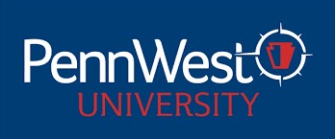

PENNSYLVANIA WESTERN UNIVERSITY
UNIVERSITY-WIDE CONTRACTUAL COMMITTEES
2024-2025 ACADEMIC YEAR

PROMOTION COMMITTEE 2024-2025 AY

College of Education, Arts & Humanities
Susan Rutledg- Morris (CAL) Education 2025
Renae Shawgo (CL) English, Philosophy & Modern Languages 2025
Jeremy Galante (ED) Visual & Performing Arts 2025

College of Health Sciences & Human Services
Janice McCall (CAL) Social Work, Sociology & Human Services 2025
Laurie Pierce (CL) Nursing & Health Professions 2025
Wayne Hawley (ED) Psychology, Counseling & Art Therapy 2025

College of Science, Technology & Business
Bismark Oduro (CAL) Chemistry, Mathematics & Physics 2026
Alawya Alawami (CL) Computing & Engineering Technology 2026
Kiarash Aramesh (ED) Biology, Earth & Environmental Sciences 2026

Non-teaching Faculty Representative
Mary Buchanan (CL) University Libraries 2026

