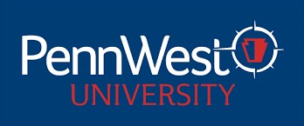

PENNSYLVANIA WESTERN UNIVERSITY
UNIVERSITY-WIDE CONTRACTUAL COMMITTEES
2024-2025 ACADEMIC YEAR

TENURE COMMITTEE 2024-2025 AY

California Campus
Louise Nicholson STB/Biology, Earth & Environmental Sciences 2025
Nik Roberts EAH/Criminal Justice, History & Politics 2025
Lindsay Hammond HS&HS/Exercise, Health, & Sport Sciences 2026

Clarion Campus
Amy Shannonhouse EAH/Education 2025
David Lott STB/Biology, Earth & Environmental Sciences 2025
Rachel Newbury Non-Teaching/University Libraries 2026

Edinboro Campus
Mary Jo Melvin EAH/Education 2025
Sheila Lorenzo de la Pena HS&HS/Psychology, Counseling & Art Therapy 2025
Nathan Fralick Non-Teaching/University Libraries 2026

