

Phone: 814-227-2420 [www.apscuf.org](http://www.apscuf.org) May 2015

**Executive Committee:** President – **Elizabeth MacDaniel;**  Vice President – **Barry Sweet;** Secretary – **James Maccaferri**; Treasurer – **Linda Lillard;** Delegates –**Elizabeth MacDaniel, Karen Bolinger, Annette Rosati, Deborah Ellermeyer; Barry Sweet; Joyce Overly**  Alternate Delegates – **Nancy Clemente, Greg Goodman, Lorie Taylor, Amy Shannonhouse, Jonathan Touster;**  Coaches President - **Al Modrzejewski** Coaches Vice President – **Ron Righter;** Venango Campus – **Paul Klenowski**; CAP – **Joseph Croskey**; DRC – **Mary Buchanan**; Grievance – **Mark Kilwein**; Health & Welfare – **Marilyn Howe**; Legislative – **Jonathan Touster**; Membership – **Rhonda Clark**; Negotiations – **Elizabeth MacDaniel**; Nominations & Elections – **Jennifer May**; Gender Issues & Social Justice – **Amy Conner-Love**; Public Affairs/Relations – **t/b/d**; Student Liaison – **Naomi Bell O’Neil**;Rules & Bylaws **– Carey Childers;** Mobilization Chair – **Laurie Miller**

**THE PRESIDENT’S MESSAGE…**

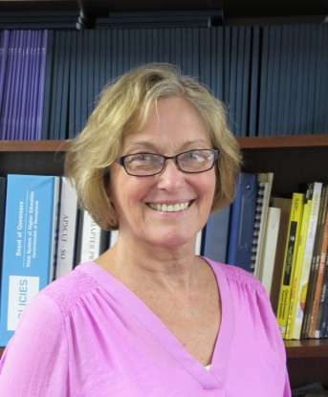Dear colleagues,

As they say, spring has sprung. Finally. And we see lovely flowers bloom and buds on trees emerge as the world turns green once more. Hallelujah!

And another semester is drawing to a close. Hallelujah!

We will soon say farewell to our graduating students, wishing them success in their new lives, new ventures. We will say goodbye for the summer to other students who will return to their studies in the fall. And we say welcome to the "newbies," the students who will be joining us in late August. The annual shuffle, you might say, of familiar faces leaving, new ones arriving.

The school year is ending. We say farewell to colleagues and friends who are retiring. A touch bittersweet, perhaps, as endings and leavings often are. We wish them warmth and happiness wherever they go, whatever their adventures may be. Our lives, and those of Clarion students, are richer for having had them with us for a time. Thank you for your service to our University, your dedication to your discipline, your commitment to this wonderful thing that we call public higher education. Thank you.

[](http://www.bing.com/images/search?q=schools+out+cartoons&view=detailv2&&&id=821624F067B1A7E705B20FE86BC6F6D03D096AB3&selectedIndex=8&ccid=2X/vwREJ&simid=607994647557179711&thid=JN.n35UjdTo0w/vvrg%2b1Oecjg)

Farewell for a time to the rest of you. My thanks for your support and your work, your commitment and your time. Together we create this place of learning, of discovery. May you have peace, light, and warm days in the weeks and months ahead, until we meet once more.

In solidarity,

Beth

**SUMMER HOURS and CLOSINGS:**

**APSCUF Office Summer Hours are from 8 am till 4:00 pm.**

**The APSCUF Office is scheduled to be closed on the following days:**

* Monday, May 18 thru Tuesday, May 19
* Friday, May 22 thru Monday, May 25
* Friday, June 5 thru Friday, June 19
* Friday, July 3
* Friday, July 24

C:\Documents and Settings\APSCUF\Local Settings\Temporary Internet Files\Content.IE5\3LLBP5QY\MC900439847[1].wmfSUMMER SCHOOL PAYMENTS FOR 2015

SUMMER SESSION I: May 29, 2015

SUMMER SESSION II: June 26, 2015

SUMMER SESSION III: July 24, 2015



**On behalf of the Faculty & Coaches of Clarion APSCUF, a generous donation was given to *The Cancer Center at Clarion Hospital* in memory of June Hetrick.**

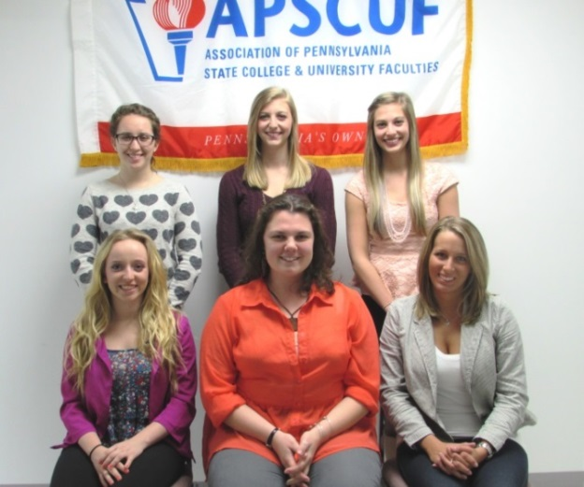

Clarion APSCUF Fall 2015 Scholarships Awarded

**CONGRATULATIONS to the following APSCUF Scholarship winners who were awarded $500 each for the Fall 2015 semester. This year there were 54 outstanding applications submitted by currently enrolled students throughout Clarion and Venango campuses. The scholarship winners were recommended by the APSCUF Scholarship Committee (Dr. Katy O’Donnell, Chair, Dr. Simon Aristeguieta and Dr. Todd Lavin) and were approved at the Executive Committee meeting on April 7, 2015.**

**Front LR:  *Sara Silka, Samantha Beal, Katie Delaney***

**CATEGORIES Back LR:  *Lauren Pellegrino; Paige Schwabenbauer; Brooke Schwabenbauer***

j0425822**Child of APSCUF Member:** Samantha Beal (English/Communication)

**Graduate:** Katie Delaney (Speech-Language Pathology)

**Senior:** Brooke Schwabenbauer (Speech-Language Pathology)

**Junior:** Sara Silka (Biology & Pre-Medicine)

**Freshman/Sophomore**: Paige Schwabenbauer (Speech-Language Pathology)

**At Large:** Lauren Pellegrino (Intervention Specialist/Early Childhood)



**REMINDER: OPEN ENROLLMENT FOR PASSHE’S HEALTH PLAN**

**Open Enrollment for PASSHE Health Plan for Active Employees is from NOW through Friday, May 8, 2015.**

**REMINDER: For Highmark members, the DEADLINE FOR PARTICIPATION in the** [**Healthy U wellness program**](http://www.passhe.edu/inside/hr/syshr/Pages/Healthy-U-Getting-Started.aspx) **is May 31, 2015. Complete the participation requirements to receive the lowest employee contribution rate for the plan year starting in July 2015. Note: Since May 31 is a Sunday, you will need to contact a Highmark Member Service Representative or your campus Human Resources office during the workweek if you require assistance.**



The participation deadline of the Healthy U wellness program is **May 31, 2015**. Both you and your covered spouse/same-sex domestic partner (if applicable) need to accumulate a minimum of **70 Healthy U points each** by the deadline of **May 31, 2015**. There are a wide variety of activities and programs that individuals can choose from to earn Healthy U points. Everyone is REQUIRED to complete the Wellness Profile (worth 30 points). If you attain 70 points without completing the Wellness Profile, you still must complete the Wellness Profile to qualify for the premium incentive. You can access Healthy U at [www.highmarkblueshield.com](http://www.highmarkblueshield.com). Log in with your Highmark user name and password, and select the “Rewards Program” link to get started.

**Need More Information or Assistance with Healthy U?**

* Call Highmark’s Member Services 1-888-745-3212 for general assistance
* Call Highmark’s Technical Support 1-877-298-3918 for website or login issues
* Contact our university’s Human Resources office for Healthy U information and resources

[](http://www.bing.com/images/search?q=retirement+clip+art&view=detailv2&&qpvt=retirement+clip+art&id=ED190063F14BECE086D5B8396014962CCF20D0F3&selectedIndex=1&ccid=sgTY02xr&simid=607994626081688129&thid=JN.RX4Uvnxp1gEyu5gOAtEe7g)**HAPPY RETIREMENT!!**

**Best Wishes to our 2014-2015 Retirees**

**Ms. Vicky Clark, Visual Arts & Sciences**

**Mr. Jay Foster, Head Football Coach**

**Dr. Greg Goodman, Education**

**Dr. Marite Haynes, Psychology**

**Dr. James Kole, Academic Enrichment (May ’14)**

**Mr. John Lovelace, Academic Enrichment**

**Dr. Brian Maguire, Education**

**Dr. Steven Piott, Social Science**

**Dr. Linda Pritchett, Nursing (Aug ’14)**

**Mr. Ron Righter, Head Men’s Basketball Coach**

**Dr. Hallie Savage, Comm. Sciences & Disorders**

**Dr. Kevin Stemmler, English & Modern Languages (Jan ’15)**

**Dr. Wayne Swanger, Special Education (July ’14)**

**Dr. Gerald Thomas, Biology & Geo-Sciences**

**Dr. Thomas Vilberg, Psychology**

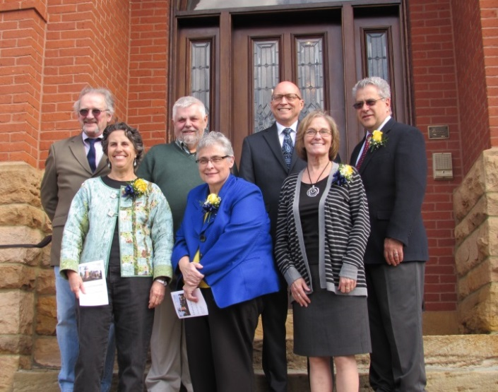

**ATTENTION NEW RETIREES: PA Faculty Health and Welfare Fund Benefits will end on the last day of the following month after your retirement date. Retirees have the option of signing up for COBRA for their Health and Welfare benefits for an 18-month period or paying for dental/vision benefits thru APSCURF, the retirement association.**

**All Clarion University APSCUF Retirees receive a one-year membership paid by Clarion APSCUF to the Association of State College and University of Retired Faculties (APSCURF). As an APSCURF member, retirees are entitled to the special services they enjoyed as an APSCUF member plus the voluntary member-paid dental/vision benefit option plan.**

**Front LR: Marite Haynes, Pres. Whitney, APSCUF Chapter**

**President Beth MacDaniel**

**Back LR: Greg Goodman, Tom Vilberg, Kevin Stemmler,**

**Provost Nowaczyk**

**EMERITUS STATUS PROCEDURES**

**Nominations for Emeritus Status should be initiated by member(s) of the appropriate department/unit and announced at a department/unit meeting, normally within one year following retirement. The nominated member(s) of the department/unit shall forward a one-page summary of the significant accomplishments made by the nominee to the Dean and appropriate Vice President.**

**The Office of the Provost and Academic Vice President will be responsible for the implementation of this policy and its procedures. The above procedures for departments to follow to request emeritus status for retiring faculty in departments are taken from the Clarion University of Pennsylvania Policy on Emeritus Status. A copy of the entire policy is available from the APSCUF office.**

**If you have faculty who are retiring at the end of the fall or spring semester in your department, please follow the procedures in this policy to request emeritus status for the nominee.**

**FOR APSCUF MEMBERS ONLY: ARE YOU REGISTERED FOR APSCUF’s “MEMBERS FORUM” SITE??**

* [http://www.apscuf.org/forum/styles/prosilver/imageset/site_logo.png](http://www.apscuf.org/forum/index.php)Log onto the APSCUF website at [www.apscuf.org](http://www.apscuf.org)
* At the top of the page click ‘Members Forum’
* At the next screen click ‘REGISTER’ above the username field
* Read guidelines and chose ‘I accept’
* Fill in form as described
* Hit ‘submit’
* You will see an email that reads “Welcome to Members Forum” forums.  It will include your username and state that your account is currently inactive and will need to be approved by an administrator at State APSCUF before you can log in. Another email will be sent when this has occurred.  Your password will be securely stored in APSCUF’s database and cannot be retrieved. In the event that it is forgotten, you will be able to reset it using the email address associated with your account.
* Second email will be sent to the State APSCUF administrator so that that person can activate the account.
* Once this occurs a second email will be sent to you saying that you can now log in.

Once you enter the “Members Forum” site, you can find information on ***Special Services*** for full-dues paying members such as discounts from Verizon Wireless, AT&T and T-Mobile, rent-a-car discounts with National and Alamo, magazines (QSP Program) and lots more. Sign up today!!

***C:\Documents and Settings\APSCUF\Local Settings\Temporary Internet Files\Content.IE5\G3L612TG\MCj02334130000[1].wmfSPRING 2014 ELECTIONS RESULTS ANNOUNCED***

**The Clarion APSCUF Nominations and Elections Committee is pleased to announce the results of the Spring 2015 General Election.**

**Thank you, all, for your interest in serving our union and our university community.  And thanks to all who participated in the election, candidates and voters; your contributions are appreciated.**

**Best wishes,**

**Jennifer May, N & E Chair**

**N & E Committee:  Chunfei Li, Amanda Lockwood, Mary Beth Mason-Baughman & Kathleen McIntyre**

***APSCUF OFFICES & APSCUF COMMITTEES***

***President:***

Elizabeth MacDaniel

***Vice President:***

Ray Feroz

***Secretary:***

James Maccaferri

***Treasurer:***

Linda Lillard

***Delegate to Legislative Assembly:***

Karen Bolinger

Annette Rosati

***Alternate Delegate to Legislative Assembly:***

Nancy Clemente

Karl Sprenger

Lorie Taylor

***Venango Campus Representative:***

Paul Klenowski

***Nominations & Elections Committee:***

Renee Bloom

YooJin Ha

***Coaches APSCUF Positions:***

***Coaches President:*** Al Modrzejewski

***Coaches Vice President:*** Dave Durish

***Coaches Grievance Chair:***  Eric Laughlin

***CONTRACTUAL COMMITTEES***

***Promotion Committee:***

Sandy Chen

Stephen Gendler

James Maccaferri

***Sabbatical Leave Committee:***

Paul Klenowski

Mark Lepore

***Tenure Committee:***

Ning Chen

Nancy Clemente

***CCPS:***

Laurie Occhipinti

Karl Sprenger

***COUNCIL ON GENERAL EDUCATION***

**School of Nursing & Allied Health**

Laurie Pierce

**Humanities and Social Sciences**

                Kathleen McIntyre



* Congratulations and Best Wishes to Clarion APSCUF Delegate Joyce Overly. She was voted in at April’s Legislative Assembly to serve as an At-Large Member of State Executive Council for the next two years.
* And to Chapter President Beth MacDaniel. She will again be serving on the State Meet & Discuss Team.

***HAVE AN ENJOYABLE AND SAFE SUMMER!!***